**Basic Concepts**

* **What type of testing would you perform if you are short on time and the user story does not have detailed acceptance criteria?**

A. Smoke testing.

**B. Exploratory tests**

C. Use case testing.

D. Inspection tests

* **What do you consider to be the ultimate goal of a Quality Analyst oriented to the execution of Non-Functional Tests?**

**R/** For me it would be to be able to improve the user experience, since as Non-Functional Test Analysts, what we seek is to guarantee that the product has good load parameters, that several users can transit at the same time, guarantee a certain level of security at the time we use the product also checking for certain standards, look for scalability between operating systems or navigators, that is, not only have the app on Android but also on iOS, another important fact for this is that as Non-Functional Tester we used to look for accessibility, for example on issues such as that all images on a webpage have tags

* **What is the purpose of this unit test?**

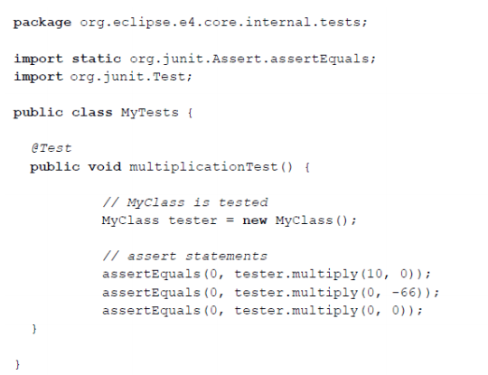

**R/** Having a *multiply* method that receives two parameters, we can assume that the tests would check the correct result of the multiplication of two numbers. But when looking at the parameters that are sent in the asserts we see that what this test really intends is to see the behavior of zero, so by sending zero as either of the two parameters, the result of the multiplication is 0 regardless of the other parameter. Something like n times zero is 0.